
Ensign Group Inc (NASDAQ: ENSG)
Healthcare Services / Skilled Nursing
United States

Stock Price Graph (5Yr)
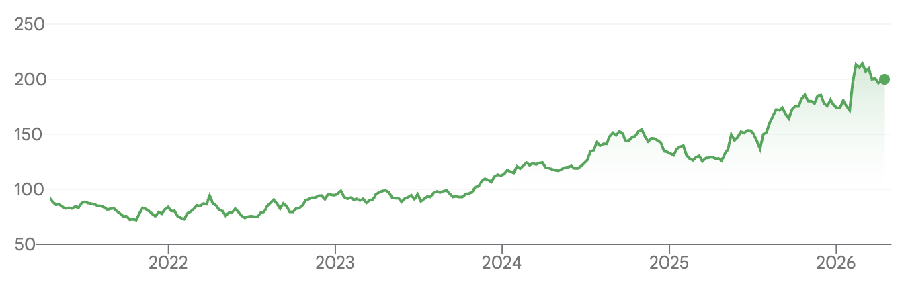

Company Overview
Ensign Group Inc. (NASDAQ: ENSG) is a is a leading provider of skilled nursing, senior living, rehabilitative care, and related healthcare services in the United States.
Founded in 1999 and headquartered in San Juan Capistrano, California, the company operates a broad network of post-acute care facilities that provide skilled nursing, therapy, assisted living, memory care, and other services for patients transitioning from hospitals or requiring longer-term care.

Ensign operates through two primary segments: Skilled Services and Standard Bearer. The Skilled Services segment includes the company’s core nursing, rehabilitation, and senior living operations, while Standard Bearer focuses on healthcare real estate ownership and leasing. This structure allows Ensign to combine an asset-light operating model with selective real estate ownership, giving the company flexibility in capital allocation and expansion. Ensign supports this platform with a decentralized operating model in which local leaders manage day-to-day operations and respond directly to the needs of their individual communities and referral partners.

Revenue by Product
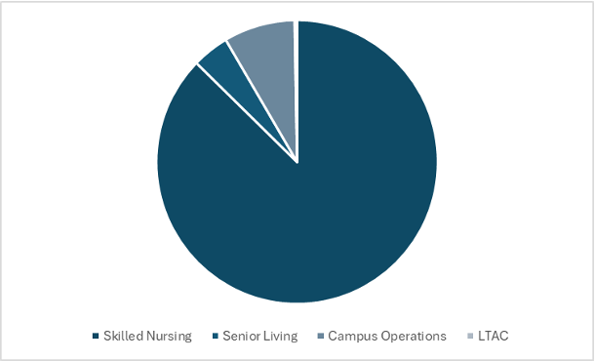
Ensign holds a differentiated position within the post-acute care industry as an operator focused on skilled nursing facilities, rehabilitation, and transitional care rather than higher-end senior housing or purely inpatient rehabilitation. The industry remains highly fragmented, with a large portion of facilities still operated by small, independent owners, creating a significant opportunity for continued consolidation. Ensign has used this fragmentation to its advantage through a disciplined acquisition strategy and a strong track record of operational improvement following acquisitions.

The company has completed more than 100 acquisitions in recent years while continuing to improve occupancy, skilled mix, and margins across its existing facilities. Standard Bearer also provides an added layer of strategic flexibility by allowing Ensign to own, lease, and finance healthcare real estate in ways that can support both operational growth and long-term value creation. With favorable demographic tailwinds, non-discretionary demand for post-acute care, and a proven model for integrating and improving acquired facilities, Ensign is well positioned to benefit from rising demand across skilled nursing and senior care over the long term.

Investment Thesis
We rate Ensign a Buy with a 5Y Target Price of $402.11 per share driven by the following thesis points:

- Strong Growth Driven by Favorable Industry Trends

Ensign benefits from strong tailwinds in post-acute care, supported by favorable demographics, rising chronic disease prevalence, and growing demand for skilled nursing and rehabilitation services. The company is positioned well within this environment because its core business is directly tied to essential care needs rather than discretionary healthcare spending, making demand more durable across economic cycles. As the 65+ and especially 80+ populations continue to expand, the addressable market for skilled nursing facilities should grow meaningfully over time, particularly as more patients require medium-length rehabilitation stays, chronic care support, and recovery services following hospital discharge.

This demand is supported by the structure of post-acute reimbursement, where skilled nursing continues to receive a large share of Medicare post-acute spending. Ensign’s focus on skilled nursing and transitional care aligns well with these trends, allowing the company to benefit not only from rising admissions, but also from a growing need for efficient, high-quality care in a fragmented industry that remains essential to the broader healthcare system.

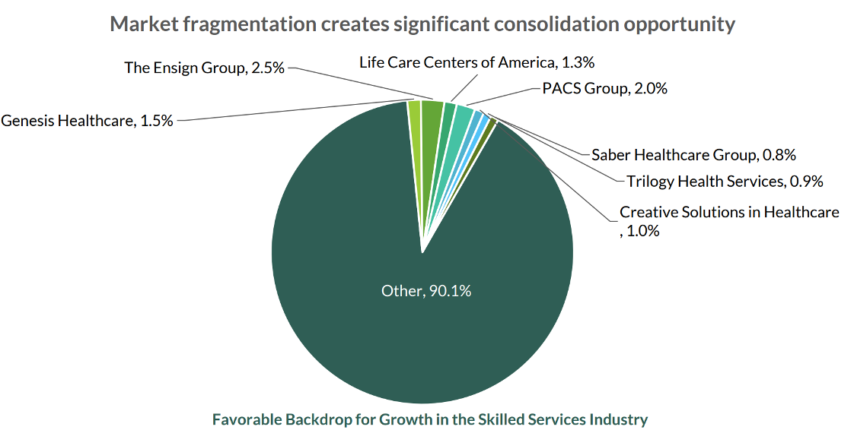

- Recession Proof with High Growth Potential

Ensign offers a rare combination of defensive characteristics and attractive long-term growth potential. Demand for skilled nursing and post-acute care is largely non-discretionary, since patients typically require these services following hospitalization, surgery, or the progression of chronic health conditions rather than as a matter of consumer choice. That makes Ensign’s core business less sensitive to economic slowdowns than many other areas of healthcare.

The company also has room to grow within its existing footprint, with occupancy still leaving meaningful capacity for additional admissions and stronger margin realization over time. This gives Ensign a path to organic growth even without relying entirely on new acquisitions. Historically, the business has also shown resilience during weaker economic periods, supported by essential service demand and a reimbursement structure tied more closely to patient need than to consumer sentiment. In our view, this creates an attractive setup where downside is supported by defensive demand while upside remains driven by utilization gains, operational improvement, and continued industry consolidation.

- Proven Acquisition Strategy and
Operational Execution

Ensign’s acquisition strategy is one of the clearest drivers of its long-term growth. The post-acute care industry remains highly fragmented, giving the company a large pipeline of potential targets, and Ensign has demonstrated an ability to acquire facilities at scale without sacrificing operational discipline. Rather than relying on heavy capital investment to create value, the company typically acquires facilities that already have the necessary infrastructure in place and improves performance through stronger leadership, better clinical execution, and deeper hospital referral relationships.

Its decentralized operating model is critical to this strategy, as local leaders are empowered to run facilities based on the needs of their specific markets while still benefiting from Ensign’s broader platform and experience. This approach has allowed the company to improve occupancy, patient mix, and margins within a relatively short period after acquisition, supporting a track record of profitable growth that appears both repeatable and scalable.

Competitive Positioning

Market: Ensign is one of the strongest operators in the post-acute care space, supported by its scale and consistent execution. It has the largest market cap among its peers, which reflects both its growth track record and investor confidence.

A key differentiator is its hybrid model. Through its Standard Bearer segment, Ensign Group, Inc. owns some of its real estate while still operating an asset-light business. This gives the company more flexibility, better control over key locations, and adds upside from real estate value, which most competitors do not have.

Ensign also runs with a relatively conservative balance sheet. Lower leverage reduces risk and gives the company room to keep acquiring facilities in a highly fragmented industry.

On profitability, Ensign generates strong and consistent margins compared to most skilled nursing operators. While some peers in higher-acuity segments have slightly higher margins, Ensign stands out within its core space due to its operational discipline and decentralized model. Overall, this combination of scale, financial strength, and execution makes it one of the most well-positioned companies in the industry.

Management: One of Ensign’s biggest strengths is its management team and overall culture. As a class, we had the opportunity to speak directly with CEO Barry Port and CIO Chad Keetch, which gave us a much better understanding of how the company actually operates. Both have been with Ensign for a long time and have helped grow it into a roughly $12 billion market cap business, which gives a lot of confidence in their leadership and long-term strategy.

When we spoke with them, we asked about what the market might be missing in terms of future growth, the outlook for Standard Bearer, and what really sets Ensign apart from competitors like PACS. One thing they kept coming back to was that everything starts with patient care. Their focus is on running high-quality facilities and doing right by patients, and they believe the financial results follow from that.

They also talked a lot about Standard Bearer and the company’s balance sheet. Because of their strong reputation and track record, they’re often able to win acquisition deals even when their bids aren’t the highest. Sellers trust Ensign to run facilities well, which gives them an edge. Owning real estate also helps, since it allows them to go after larger portfolio deals that some competitors can’t.

When discussing competitors, they described Ensign as more disciplined and less aggressive. They focus on staying compliant and not pushing boundaries, which stands out compared to some operators that have run into regulatory issues.
Overall, both leaders came across as very humble but also confident in where the company is headed. Their focus on patients, combined with a disciplined approach to growth, makes it clear why Ensign has been able to execute so consistently.
Moat: Ensign’s competitive advantage comes from its operating model, capital flexibility, and experience in a complex industry.
First, its decentralized structure allows each facility to respond to local needs and build strong relationships with nearby hospitals. In skilled nursing, referrals drive occupancy, and Ensign’s focus on local leadership helps create steady referral pipelines that are hard to replicate.
Second, the company has a proven acquisition strategy in a highly fragmented market. Its track record of improving underperforming facilities has built a strong reputation, which helps it consistently win deals and continue growing.
Third, Ensign’s mix of operations and real estate ownership through Standard Bearer gives it more flexibility than most competitors. Management noted that the company has built up significant cash, making capital allocation a key focus going forward. This allows Ensign to keep investing in growth without relying heavily on outside financing.
Finally, Ensign operates in a highly regulated industry and has shown it can stay compliant while still growing. This creates a barrier to entry and sets it apart from competitors that have taken more aggressive approaches and faced regulatory issues.
Margin of Safety: Ensign’s margin of safety is supported by the stability of its underlying business and consistent demand for its services. Skilled nursing and post-acute care are largely non-discretionary, as patients require care following hospital stays or due to chronic conditions. This creates a steady demand base that is less sensitive to economic cycles. In addition, Ensign has a strong track record of improving facility performance, which allows it to drive growth through higher occupancy and better operations even without relying entirely on acquisitions.
The company’s balance sheet provides another layer of protection. Ensign Group, Inc. operates with relatively low leverage and has built up significant cash, giving it flexibility to navigate downturns and continue investing in growth opportunities. Its exposure to real estate through Standard Bearer also provides underlying asset value and more stable long-term cost control. Together, these factors help limit downside risk while still supporting long-term upside.
Risks

Reimbursement: One of the primary risks for Ensign Group, Inc. is its exposure to Medicare and Medicaid reimbursement. Because a large portion of revenue is tied to government programs, changes in reimbursement rates or policies could directly impact margins. While Ensign has historically operated efficiently within this system, any meaningful reduction in reimbursement would put pressure on profitability. At the same time, Medicare spending allocated to skilled nursing facilities is expected to increase as the healthcare system continues shifting patients from hospitals to lower-cost post-acute settings, which supports long-term demand.
Labor Risk: Labor availability remains a key operational risk. Skilled nursing is highly labor-intensive, and ongoing nursing shortages can limit Ensign Group, Inc.’s ability to fully capture demand. Even if occupancy opportunities exist, a lack of staffing can prevent facilities from operating at full capacity and may lead to higher labor costs.

Staffing shortages can also impact quality of care and lead to lower ratings under the CMS Five-Star Quality Rating System, which can affect a facility’s reputation and its ability to attract patients and referrals. This creates both operational and financial pressure if not managed effectively.

High Price Tag: Valuation is an important risk to consider. Ensign is currently trading at around 35x P/E, which is above its 5-year average of roughly 27x and higher than many of its peers. This premium reflects the company’s strong execution and consistent growth.
At the same time, it leaves less room for error. If growth slows, margins come under pressure, or sentiment shifts, the stock could see multiple compression even if the business is still performing well.
Valuation
We applied 3 different methods to derive a 5-year target price of $402.11 for Ensign. These methods include DCF (33%), TEV/EBIDTA (33%), and PE (33%).

For the DCF method, we used a WACC of 7.00%, and a perpetuity growth rate of 4%. We also included our own differentiated revenue model which showed growth of 18%, 10% and 11% over the next 3 years. We did not include a differentiated model for the CAPEX or the margins. However, within our revenue model we did include improving margins which contributed to revenue growth.

Revenue Model: For our revenue model we created a differentiated view based on two main aspects. We believe in an increased growth rate for occupancy usage. A recovery that would put at pre COVID levels. Additionally, we see a stronger growth in the number of older person population needing to utilize nursing homes. These are both illustrated in our model below.

Management Profile
Barry Port – Chief Executive Officer & Chairman
Barry Port has served as CEO since 2019 and became Chairman of the Board in 2025. He has been with Ensign Group, Inc. for over two decades and has held several leadership roles across the organization. His background in operations and long tenure with the company have been key to Ensign’s consistent execution, decentralized culture, and successful expansion strategy.
Chad Keetch – Chief Investment Officer, EVP & Secretary
Chad Keetch has served as Chief Investment Officer since 2019 and is responsible for Ensign’s acquisition strategy, capital allocation, and real estate platform, including Standard Bearer. He has played a major role in scaling the company’s footprint and has extensive experience in healthcare transactions, financing, and strategic growth initiatives.
Suzanne Snapper – Chief Financial Officer & EVP
Suzanne Snapper oversees Ensign’s financial operations, including accounting, reporting, and capital management. She has been with the company for many years and brings deep experience in financial oversight within healthcare services. Her leadership supports disciplined capital allocation and financial stability as the company continues to grow.
Spencer Burton – President & Chief Operating Officer
Spencer Burton leads Ensign’s day-to-day operations and supports performance across its network of facilities. With nearly two decades at the company, he has extensive experience in skilled nursing operations and plays a key role in maintaining Ensign’s decentralized model and strong operational execution.

Key Financials

Competitor Data

￼￼

